MEMO IN CASE OF A TERRORIST ATTACK

Department of Information Policy
and Integrated Security

In case of an armed attack

If you heard the sounds of gunshots, explosions, screams, or saw an armed man/people:
- If the shooter is far away and doesn’t see you, leave the place if possible and call 112;
- If the shooter is nearby, hide in the nearest room;
- Lock and barricade the door with furniture and improvised means;
- Get away from doors and windows, lie down on the floor, and don't make any noise;
- Switch your phone to silent mode and report the attack by calling 112;
- Inform your loved ones about the situation (SMS, call), speak softly.

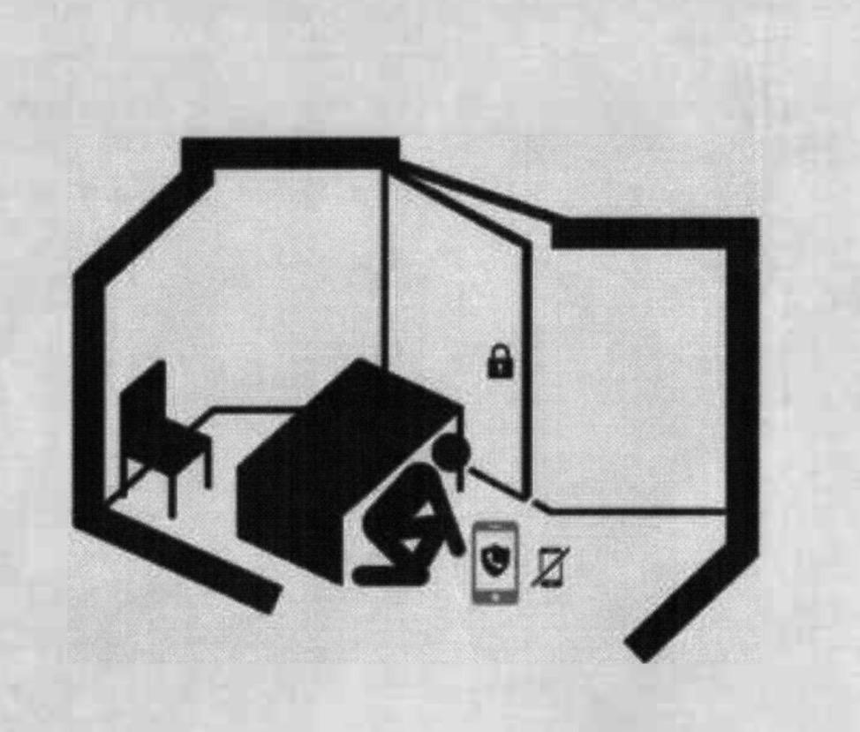

In case of an armed attack

In case of storming of the building:
- Lie on the floor away from doors and windows, cover your head with your hands and do not move;
- When you see law enforcement officers, keep your hands in plain sight, do not make sudden movements, follow their instructions;
- In no case, do not run towards or away from law enforcement officers, they may mistake you for a criminal.

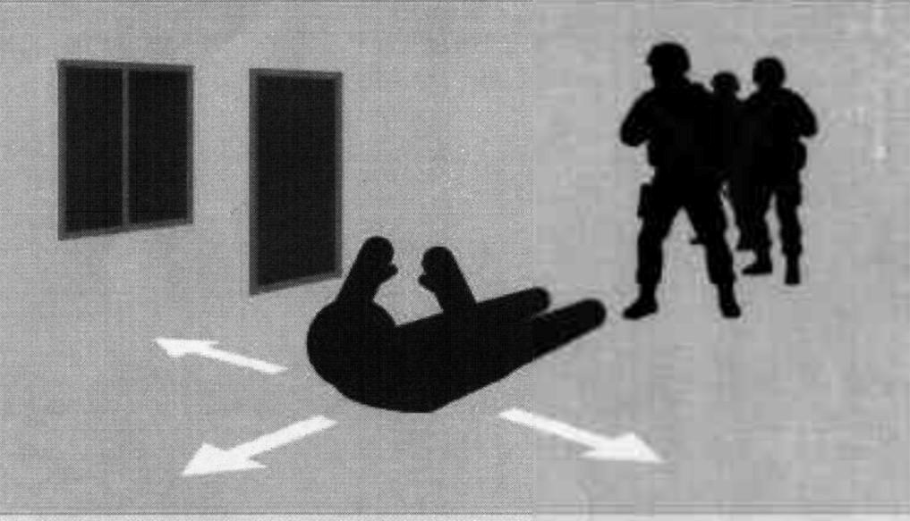

In case of hostage situation

Your main goal is to stay alive!

Be prepared for the use of blindfolds, gags, handcuffs or ropes by terrorists, and endure hardships, insults and humiliations.

- Do not allow any actions (ex.: unexpected movement or noise) that may provoke terrorists to use weapons and lead to human casualties;
- Don't look terrorists in the eye, don't act defiant. (this is a signal to aggression for a nervous person);
- Do not try to resist, do not act unnecessary heroic, trying to disarm the bandit break through the exit (window);
- If you are forced to leave the building, saying that you have been taken hostage, do not resist.

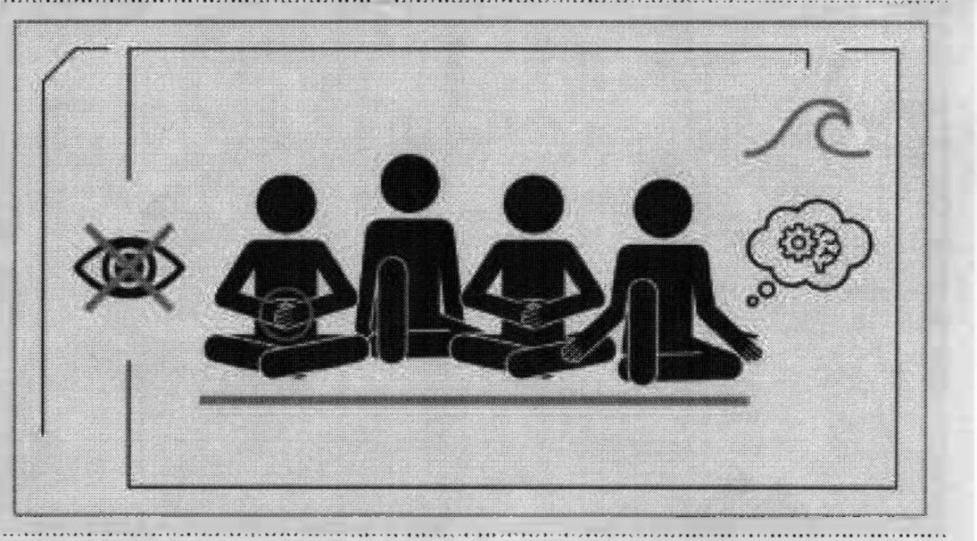

In case of hostage situation

- If necessary, comply with the demands of criminals, do not contradict them, do not risk the lives of others and your own, try to avoid hysteria and panic;
- When medical attention is needed, speak calmly and briefly, without irritating the criminals, do not do anything until you get permission;
- Try to remember the signs of criminals, distinctive features of their faces, clothes, names, nicknames, possible scars and tattoos, speech patterns and behaviors, topics of conversation, etc.

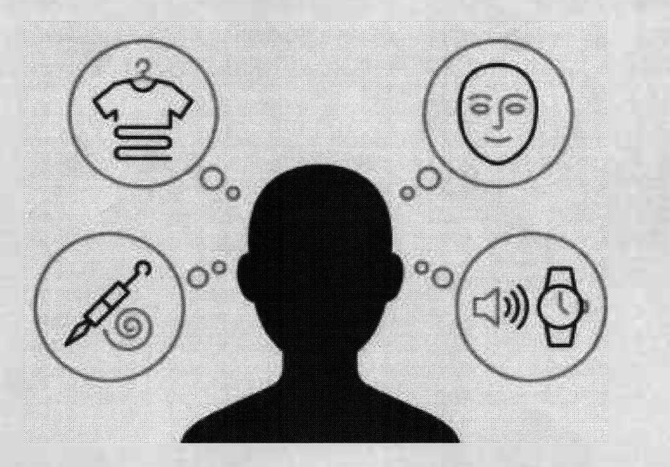

In case of hostage situation

During the hostage rescue:
- Lie face down on the floor, cover your head with your hands and do not move;
- If possible, stay away from doors and windows;
- When you see law enforcement officers, keep your hands in plain sight, do not make sudden movements, follow their instructions;
- In no case, do not run towards or away from law enforcement officers, they may mistake you for a criminal.

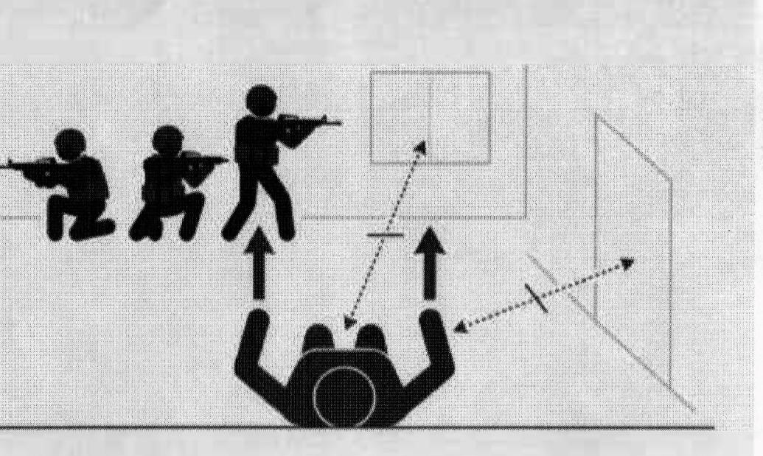

In case of an unmanned aerial vehicle attack
- If you are outside, quickly hide in a shelter (underpass, subway, basement, shelter) or lie down on the ground. Stay away from the glass!
- If you are in a transport, leave it and take cover.;
- If you are in the office, go out into the corridor;
- If you are in the building, go down to the lower floors, to the basement, to the parking lot. Do not use the elevator! Take a place without windows, between load-bearing walls, and sit on the floor;
- When detecting a UAV or its parts, do not touch anything. Do not use a phone or any other devices near this place, quickly leave the place of detection of the UAV, warning of the danger of oncoming people;
- Inform about the location of the attack/detection of the UAV by calling 112.

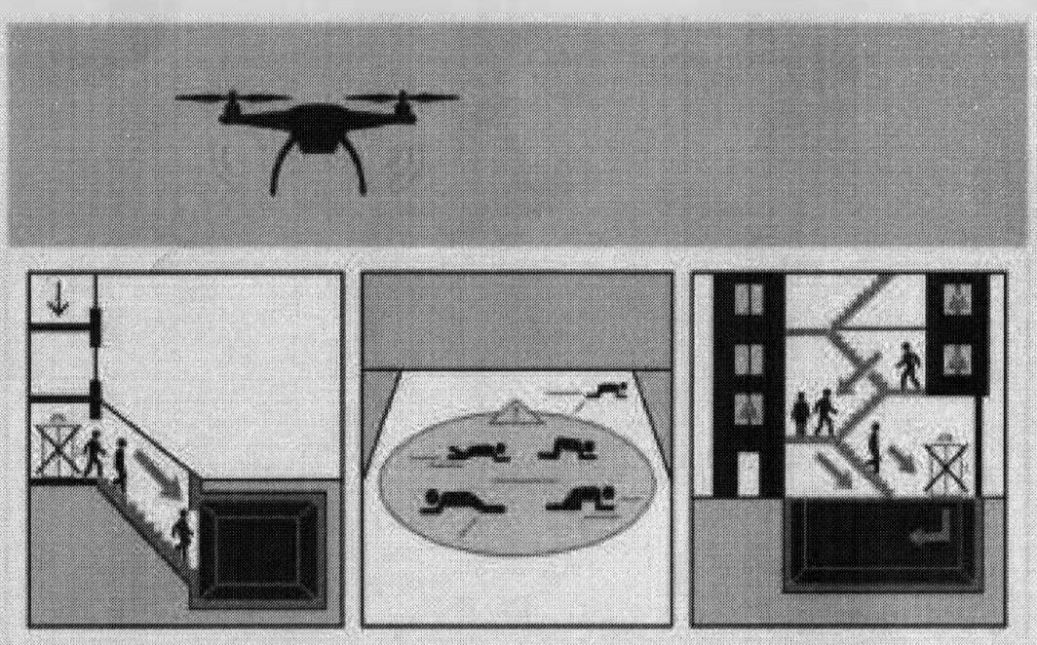

In case of detection of suspicious objects

A suspicious object can be anything: a bag, a backpack, a package, a bundle, a jar, a bottle, a box, a phone and other small electronics items, toys, etc.

An explosive device may be indicated by:
- The presence of wires, small antennas, electrical tape, twine, rope, tape;
- The noise from detected objects, such as the ticking of a clock, clicks, etc.;
- The presence of batteries on the item;
- The extensions made of wire, ropes, twine, fishing line;
- The unusual placement of the item;
- The presence of an object unusual for the area;
- A peculiar smell.

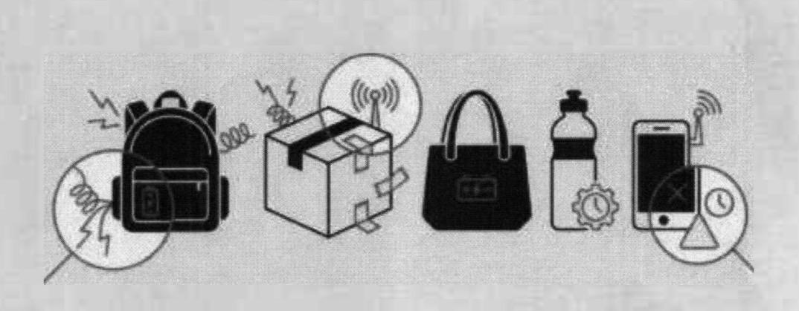

In case of detection of suspicious objects

Your actions:
- Do not touch anything!
- Do not use a phone or other devices near the object;
- Record the time of object detection;
- Take measures to get people as far away from the suspicious object and the danger zone;
- Report the discovery to security.

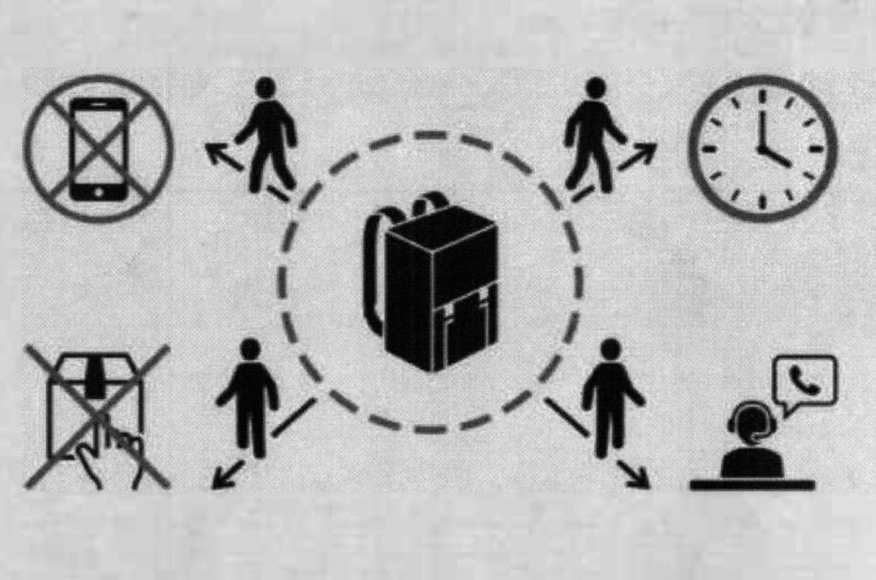

In case of explosion device detonation

Stay calm and don’t panic!

Your actions:
- If possible, fence off the location of the explosive device (with a chair, briefcase, etc.);
- if you are near the explosion site, leave the danger zone, taking the nearby people with you.;
- Disconnect all the devices;
- Stay at a safe distance from the explosion site until the security officer arrives, then act according to his instructions.

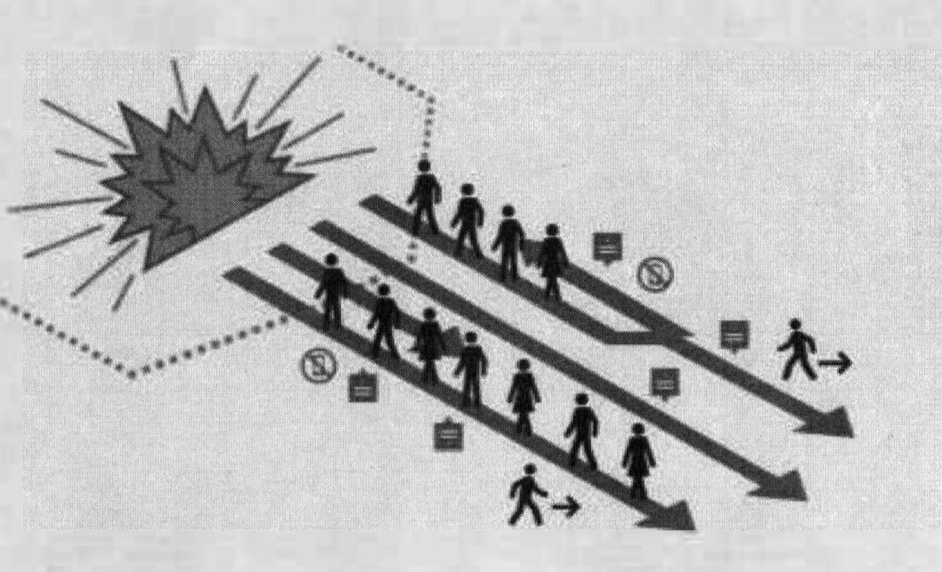

In case of explosion device detonation

If you are inside the building:
- Turn off the all the devices, electricity and gas supply, after making sure that there are no people in elevators and other rooms, the exit from which may be blocked during a power outage;
- If possible, open windows and doors to disperse the shock wave in case of possible re-detonation;
- Proceed to the gathering place in accordance with the evacuation plan. Do not forget warm clothes in winter, take all possible measures to avoid frostbite.

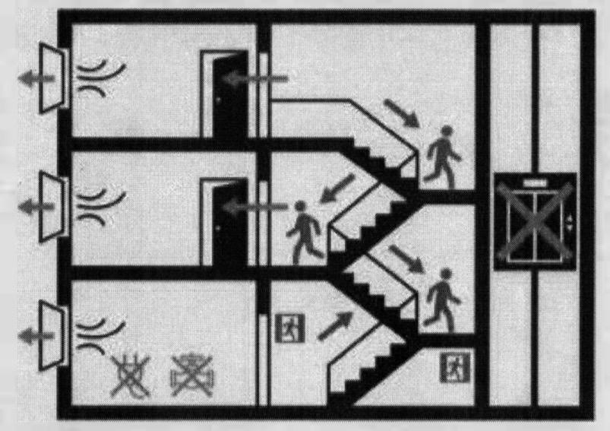

BE ALERT AND CAREFUL!

In case of a threat, call 112 immediately.

REMEMBER:
- Your safety is in your hands;
- Stay calm;
- Follow the instructions of the experts;
- Warn your loved ones about the danger.

